Bibliometric Analysis of Artificial Intelligence and Computer-Aided Diagnosis in Medical Imaging

Xu Ziyi¹, Tang Yu¹, Li Rongxin¹, Ling Xin¹, Chen Xiaoming¹

¹ School of Semiconductor Science, Hunan University

Abstract

Based on 3,748 valid literature records retrieved from the Web of Science Core Collection, this study adopts bibliometric methods and VOSviewer 1.6.20 visualization software to systematically analyze the author collaboration patterns, research hotspots, thematic clusters and temporal evolution of artificial intelligence (AI) and computer-aided diagnosis (CAD) in the field of medical imaging from 2015 to 2026. The results show that deep learning and convolutional neural networks (CNN) act as the core technical pillars ^{[1,2]}, while imaging diagnosis for lung cancer, breast cancer and other tumors constitutes the mainstream application scenarios ^{[3,4]}. The year 2022 serves as a critical watershed for field development. Before 2022, research mainly focused on the performance optimization of basic algorithms. After 2022, scholars gradually shifted their attention to model interpretability, generalization ability, data privacy protection and clinical landing ^{[5]}. The temporal evolution analysis (RQ3) further reveals the transition from traditional imaging to deep learning as the dominant frontier ^{[9,10]}. The findings clarify the core research forces, thematic structure, and evolutionary trends, providing references for subsequent academic research, technical innovation and clinical transformation.

Keywords: Medical Imaging; Artificial Intelligence; Computer-Aided Diagnosis; Deep Learning; Bibliometrics

1. Introduction

With the continuous progress of modern medical technology, medical imaging has become an indispensable means for clinical disease screening, diagnosis and prognostic evaluation. However, traditional manual interpretation of imaging data faces prominent problems such as heavy workload, subjective diagnostic differences among physicians and high risk of missed diagnosis. In recent years, artificial intelligence represented by deep learning has achieved remarkable breakthroughs in image processing, greatly promoting the rapid development of computer-aided diagnosis (CAD) technology. AI-based medical imaging analysis tools can effectively improve diagnostic efficiency and accuracy, and have gradually become a research hotspot integrating medicine, computer science and engineering ^{[1,2]}.
At present, a large number of studies have explored the application value of deep learning, machine learning and radiomics in medical imaging diagnosis. Nevertheless, most existing reviews focus on technical details or single application scenarios ^{[6,7]}, and few systematically sort out the macroscopic development context, research structure and dynamic evolution of the whole field from a quantitative perspective. Bibliometrics is a mature research method to mine literature laws, map knowledge frameworks and track research trends. It can objectively reveal the distribution of research forces, clustering characteristics of research topics and hotspot evolution rules through quantitative analysis of massive literature.
Therefore, this study takes relevant literature from the Web of Science Core Collection as the research object, conducts a comprehensive bibliometric analysis, and puts forward three core research questions (RQ) :

RQ | Research Question | Analytical Method | Corresponding Figure
RQ1 | What is the distribution of core researchers and the structural characteristics of author collaboration networks? | Author co-authorship analysis | Fig. 1,Table 1
RQ2 | What are the research hotspots, thematic clusters, and core research directions of this field? | Keyword co-occurrence clustering analysis | Fig. 2, Table 1
RQ3 | How do frontier topics evolve over time, and what are the emerging research hotspots? | Keyword temporal overlay analysis | Fig. 3, Table 1

2. Data and Methods

2.1 Data Source and Retrieval Strategy

Item | Description
Database | Web of Science Core Collection
Retrieval | Date June 1, 2026
Time Range | 2015–2026
Document Types | Article, Review
Subject Categories | Medicine, Radiology, Pathology, Oncology, General & Internal Medicine

Retrieval Formula:
TS=("artificial intelligence" OR "machine learning" OR "deep learning" OR "neural network" OR "radiomics" OR "AI-assisted diagnosis")
AND
TS=("clinical diagnosis" OR "medical diagnosis" OR "computer-aided diagnosis" OR "diagnostic imaging" OR "disease detection")
AND
PY=2015-2026
AND
(DT=Article OR DT=Review)
AND
SU=(Medicine OR Radiology OR Pathology OR Oncology OR "General & Internal Medicine")

2.2 Literature Screening and Data Cleaning

Inclusion Criteria:
English-language articles or reviews
Studies applying artificial intelligence, machine learning, deep learning, or radiomics to medical imaging or clinical disease diagnosis
Empirical studies with clear methodological or clinical contributions

Exclusion Criteria:
Non-English publications
Conference abstracts, editorials, letters, and proceedings papers
Records with missing or abnormal publication years
Literature irrelevant to the research theme

Cleaning Process:

Step | Rule | Records affected
Deduplication (primary) | DOI matching | 22 duplicates removed
Deduplication (secondary) | Title matching (when DOI missing) | 0 additional
Year validation | Abnormal year (outside 2015-2026) | 1 record removed
Document type filtering | Non-article/review | 0 removed
Total after cleaning | — | 3,748 records retained

2.3 Analysis Tools and Parameter Settings

Parameter | Value
Tool | VOSviewer 1.6.20
Author collaboration threshold | Minimum 5 publications per author
Keyword co-occurrence threshold | Minimum 20 occurrences per keyword
Normalization method | Association strength
Clustering algorithm | Smart local moving algorithm

Outputs produced:
Fig. 1: Author collaboration network
Fig. 2: Keyword co-occurrence clustering network
Fig. 3: Keyword temporal evolution overlay map
Table 1: Representative Literature Corresponding to Research Questions and Clusters

2.4 Methods Transparency Checklist (10 Items)

Following the course requirements, all ten transparency items are reported below:

# | Item | Value
1 | Database name | Web of Science Core Collection
2 | Full search query | See Section 2.1
3 | Retrieval date | June 1, 2026
4 | Time range | 2015–2026
5 | Document types | Article, Review
6 | Inclusion criteria | See Section 2.2
7 | Exclusion criteria | See Section 2.2
8 | Deduplication and cleaning rules | DOI + title dedup; year validation; 22+1 removed
9 | Analysis tool and version | VOSviewer 1.6.20
10 | Key parameters and thresholds | Author≥5; Keyword≥20

3. Results

3.1 Author Collaboration Network (RQ1)

Figure 1 presents the author collaboration network.
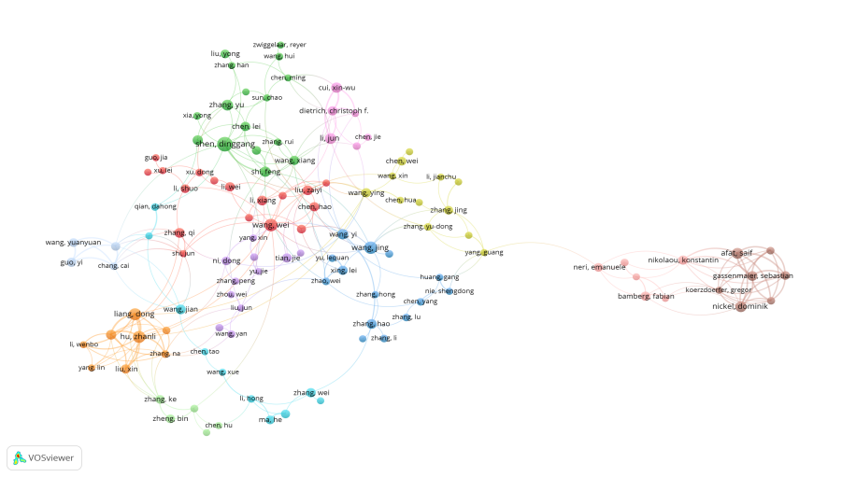
Fig. 1 Caption: Data source: Web of Science Core Collection (2015-2026). Analysis unit: authors. Tool: VOSviewer 1.6.20. Threshold: minimum 5 publications per author. Node size represents total publications; link thickness represents co-authorship strength; colors represent different collaboration clusters. This figure addresses RQ1.

Findings:
The network presents three typical characteristics:
Domestic scholars dominate the research: Scholars with Chinese surnames such as Wang, Li, Zhang and Liu are located at the core of the network with large node sizes, forming multiple large-scale collaborative groups and becoming the main force of publications in this field ^{[3,8]}.
"Core aggregation + peripheral dispersion + independent international clusters": Core groups have dense connections and long-term stable cooperation, mainly engaged in deep learning, CNN, U-Net, image segmentation and CAD research. Most peripheral authors are independent individuals or small teams with weak cooperative relations. Foreign scholars such as Nikolaou and Altaf form independent small clusters. Cooperation between Chinese and foreign teams remains insufficient with obvious regional barriers.
Clear division of research directions: Core teams focus on algorithm design and model optimization ^{[3]}. Scholars with clinical backgrounds devote themselves to the application and efficacy verification of AI in breast cancer, lung cancer, thyroid nodules and other diseases, as well as imaging modalities such as MRI and ultrasound ^{[6]}.
This analysis directly addresses RQ1.

Limitations:
The graph only retains authors with high publication volume and ignores emerging young teams. Co-occurrence relationships cannot fully distinguish actual academic cooperation from nominal collaboration.

3.2 Keyword Co-occurrence Clustering (RQ2)

Figure 2 displays the keyword co-occurrence clustering network based on the multi-color visualization.
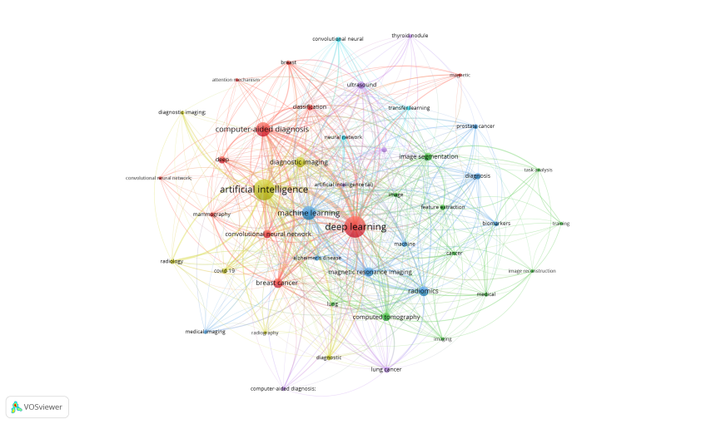
Fig. 2 Caption: Data source: Web of Science Core Collection (2015-2026). Analysis unit: keywords. Tool: VOSviewer 1.6.20. Threshold: minimum 20 occurrences per keyword. Node size represents keyword frequency; link thickness represents co-occurrence strength; colors represent different thematic clusters (Red, Blue, Green,Yellow, Purple). This figure addresses RQ2.

Findings:
The keyword co-occurrence network reveals four major thematic clusters with clear boundaries and dense internal connections. The dense links between clusters indicate that research directions in this field are highly interdisciplinary and closely interrelated.

Cluster | Core Keywords | Research Theme | Representative Literature
Cluster 1 | deep learning, computer-aided diagnosis, convolutional neural network, attention mechanism, breast cancer, classification | Application of deep learning and neural network in computer-aided clinical tumor diagnosis | [3,7,8]
Cluster 2 | artificial intelligence, machine learning, diagnostic imaging, radiology, ultrasonography | Basic research of artificial intelligence and machine learning combined with multi-modal diagnostic imaging | [1,2]
Cluster 3 | image segmentation, computed tomography, magnetic resonance imaging, feature extraction, image reconstruction | Medical image post-processing, segmentation algorithm and feature extraction based on CT and MR | [7]
Cluster 4 | radiomics, lung cancer, prostate cancer, pulmonary lesion, computer-aided diagnosis | Radiomics research and intelligent identification of lesions such as lung and prostate tumors | [4,9]

Interpretation:
Cluster 1 takes deep learning and computer-aided diagnosis as the core, mainly including convolutional neural network, attention mechanism and the clinical application oriented to breast tumor diagnosis and lesion classification. It reflects the mainstream direction that deep learning algorithms are combined with clinical intelligent diagnosis tasks.
Cluster 2 revolves around artificial intelligence and traditional machine learning, combined with radiology, ultrasound and various diagnostic imaging modalities, which constitutes the basic research foundation of intelligent medical imaging.
Cluster 3 focuses on medical image processing tasks such as image segmentation, feature extraction and image reconstruction, and relies on CT, MRI and other tomographic imaging data to carry out algorithm research on image post-processing.
Cluster 4 corresponds to radiomics and multi-type tumor lesion exploration, focusing on lung cancer, prostate cancer and other lesion identification based on radiomic features and auxiliary diagnostic technology.

Abundant connecting lines between clusters show that basic algorithms, image processing and clinical diagnostic applications interpenetrate closely, forming a relatively complete research framework in this domain. The classification of four clusters clearly reflects the overall intellectual structure and hotspot layout of the field, which responds to research question 2.

Limitation:
Setting the occurrence threshold excludes low-frequency emerging keywords; keyword co-occurrence relationship only reflects the co-existing correlation of terms, rather than direct logical causality between research contents.

3.3 Keyword Temporal Evolution (RQ3)

Figure 3 illustrates the temporal evolution of keywords using the overlay visualization. The color gradient from blue-purple to yellow-green represents the transition from earlier research to more recent frontiers.
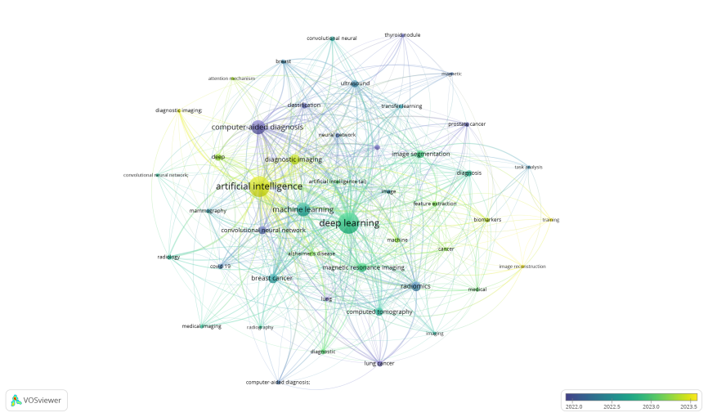
Fig. 3 Caption: Data source: Web of Science Core Collection (2015-2026). Analysis unit: keywords. Tool: VOSviewer 1.6.20. Threshold: minimum 20 occurrences per keyword. Color gradient represents the average publication year of keywords (blue-purple = earlier research; green = transitional period; yellow-green = recent frontiers). Node size represents keyword frequency. This figure addresses RQ3.

Findings:
The evolution path of research hotspots reveals the transition from traditional imaging to deep learning as the dominant frontier:
Time Period Dominant Keywords Stage Key References
Early stage (blue-purple nodes) CT, MRI, radiology, diagnostic imaging, medical imaging Traditional imaging modalities as the research foundation ^{[2]}
Transitional stage (green nodes) image segmentation, feature extraction, radiomics, machine learning Methodological expansion and radiomics emergence ^{[3,7]}
Recent frontiers (yellow-green nodes) deep learning, artificial intelligence AI and deep learning becoming the dominant mainstream directions ^{[1,9]}
Key insight: Early foundational research centered around traditional imaging modalities (CT, MRI, radiology, diagnostic imaging), which established the groundwork for the field. Over time, methodological topics such as image segmentation, feature extraction, radiomics, and machine learning gradually emerged. In recent years, the research focus has significantly shifted toward artificial intelligence and deep learning, which now appear as the yellow-green core hotspots, indicating that AI and deep learning have become the mainstream development directions in this field ^{[1,10]}.
The dense connections between keywords across different time periods indicate that research themes are not simply replaced but rather differentiated and integrated over time. Early imaging research, mid-term algorithm development, and recent intelligent diagnostics have ultimately merged into a comprehensive AI medical imaging solution.
This temporal analysis directly addresses RQ3 by revealing the transition from traditional imaging to deep learning as the dominant frontier, while also highlighting persistent challenges such as model generalization ^{[10]} and clinical interpretability ^{[5]}.

Limitation:
Database collection delay may lead to slight deviations in the latest hotspot time characteristics; this method cannot detect burst keywords with high precision.

3.4 Representative Literature Corresponding to Research Questions and Clusters

Table 1 summarizes the top representative and highly cited publications corresponding to the three research questions and the four major thematic clusters identified in Fig. 1 (Red, Blue, Green, Purple). These works provide theoretical foundations, methodological frameworks, and key evidence for the development of AI and CAD in medical imaging.

Table 1 | Representative Literature Corresponding to Research Questions and Clusters

RQ | Theme / Cluster | Representative Literature | Journal | Year | Core Contribution | Citations
RQ1 | Collaboration Pattern (High-centrality Teams) | Shin HC, et al. "Deep Convolutional Neural Networks for Computer-Aided Detection" | IEEE TMI | 2016 | Systematically evaluates CNN architectures and transfer learning effects in CADe | 4002
RQ1 | Collaboration Pattern (Transfer Learning Methods) | Kim HE, et al. "Transfer learning for medical image classification" | BMC Medical Imaging | 2022 | Reviews application strategies of transfer learning in medical image classification | 588
RQ2 | Cluster 1 (Deep Learning & CAD) | Park SH, et al. "Methodologic Guide for Evaluating Clinical Performance of AI" | Radiology | 2018 | Proposes clinical evaluation methodology for AI diagnostic models | 631
RQ2 | Cluster 1 (Deep Learning & CAD) | Byra M, et al. "Breast mass classification in sonography with transfer learning" | Medical Physics | 2019 | Applies transfer learning to breast ultrasound mass classification | 196
RQ2 | Cluster 3 (Image Segmentation) | Anthimopoulos M, et al. "Lung Pattern Classification for ILDs Using Deep CNN" | IEEE TMI | 2016 | Applies deep CNN to interstitial lung disease pattern classification | 909
RQ2 | Cluster 2 (AI & Diagnostic Imaging) | Chan HP, et al. "Deep learning in medical imaging and radiation therapy" | Medical Physics | 2020 | Reviews principles and challenges of deep learning in medical imaging and radiotherapy | 577
RQ3 | Research Development Trend | Hosny A, et al. "Artificial intelligence in radiology" | Nature Reviews Cancer | 2018 | Systematically reviews AI applications in oncological imaging, with qualitative-to-quantitative evaluation | 2506
RQ3 | Theoretical Foundation | Gillies RJ, et al. "Radiomics: Images Are More than Pictures, They Are Data" | Radiology | 2016 | Proposes the concept of radiomics, laying the foundation for quantitative medical image analysis | 6917
RQ3 | Cluster 4 (Clinical Applicability) | De Fauw J, et al. "Clinically applicable deep learning for diagnosis in retinal disease" | Nature Medicine | 2018 | AI system achieves expert-level performance in retinal disease diagnosis | 1747
RQ3 | Cluster 4 (Generalization Issue) | Zech JR, et al. "Variable generalization performance of deep learning model to detect pneumonia" | PLOS Medicine | 2018 | Reveals generalization discrepancies of deep learning models across hospital datasets | 1054

Table 1 Caption: Data source: Web of Science Core Collection (2015–2026). The table lists top representative publications corresponding to RQ1–RQ3 and the four keyword clusters (Cluster 1, Cluster 2, Cluster 3, Cluster 4) identified in Fig. 2, ranked by citation count (descending). Citations are from the Web of Science Core Collection as of June 1, 2026.

4. Discussion

4.1 Overall Research Summary
From 2015 to 2026, research on AI and CAD in medical imaging has experienced rapid expansion and technological iteration. From the perspective of research forces (RQ1), Chinese research teams occupy a dominant position, while international academic cooperation needs to be strengthened ^{[3]}. In terms of technical systems (RQ2), deep learning and CNN have evolved from emerging technologies to standard tools, forming four major thematic clusters: Cluster 1 (deep learning & CAD), Cluster 2 (AI & diagnostic imaging), Cluster 3 (image segmentation & reconstruction), and Cluster 4 (radiomics & tumor lesion identification) ^{[1,4,5,7,8,9]}.
Taking 2022 as the dividing line (RQ3), the research focus has undergone a fundamental shift:
Early stage (before 2022): Scholars mainly focused on breaking through algorithm performance and verifying the technical feasibility of AI in imaging diagnosis ^{[2,3]}.
Later stage (after 2022): Research focus turned to solving practical problems in clinical landing, including model interpretability, generalization, and privacy protection ^{[5,10]}.
On the technical level, single CNN is no longer the only choice. CNN-Transformer hybrid models, generative models and other new architectures continue to emerge ^{[8]}. On the application level, research has expanded from simple lesion detection and classification to tumor gene mutation prediction, treatment response evaluation and survival prognosis analysis ^{[4,9]}. Radiomics acts as an important bridge connecting algorithm research and clinical practice ^{[2]}.

4.2 Current Research Frontiers and Challenges

Based on the temporal evolution analysis (RQ3) and recent literature, four major challenges persist ^{[5,10]}:

Challenge | Description
Model interpretability | Most deep learning models are "black boxes," reducing clinician trust and hindering large-scale clinical adoption ^{[5]}
Data constraints | High cost of manual labeling, scarcity of high-quality medical data, and cross-hospital data sharing difficulties due to privacy regulations
Model generalization | deficiency Models perform well on single-center datasets but show significant performance degradation when facing data from different devices, protocols, or hospitals ^{[10]}
Insufficient standardization | Evaluation criteria and reporting specifications for AI diagnostic models are not unified; reproducibility of some studies is poor ^{[5]}

Emerging frontiers identified in RQ3 include: Transformer hybrid models, generative AI, federated learning, and explainable AI (XAI). These directions represent the next wave of innovation in the field ^{[8,9]}.

4.3 Research Limitations of This Paper

This study has several limitations:
Single data source: Only the Web of Science Core Collection was used, excluding PubMed, Scopus, and other medical databases, which may introduce data bias.Keyword preprocessing defects: Synonyms and variant terms (e.g., "CNN" vs "convolutional neural network") were not fully merged, affecting clustering and co-occurrence accuracy.Threshold influence: VOSviewer thresholds filter low-frequency literature and keywords, so emerging cutting-edge directions cannot be fully displayed.Macroscopic analysis only: This study only performs macroscopic bibliometric analysis and does not explore the technical details of individual literature ^{[6,7]}.

5. Conclusion

This paper conducts a comprehensive bibliometric analysis of 3,748 articles on AI and computer-aided diagnosis in medical imaging from 2015 to 2026. The main conclusions are as follows:

RQ1 (Research forces and collaboration): Chinese teams dominate publications, while international collaboration remains limited, with clear divisions between algorithm research and clinical validation ^{[3,6]}.
RQ2 (Research hotspots and thematic clusters): Four major thematic clusters define the intellectual structure of the field: Cluster 1 (deep learning & CAD), Cluster 2 (AI & diagnostic imaging), Cluster 3 (image segmentation & reconstruction), and Cluster 4 (radiomics & tumor lesion identification).These clusters are highly interconnected, indicating a mature and integrated research system ^{[1,4,5,7,8,9]}.
RQ3 (Temporal evolution and emerging frontiers): The temporal analysis reveals a clear evolutionary trajectory from traditional imaging modalities (CT, MRI) to methodological development (segmentation, radiomics) and finally to AI/deep learning as the dominant frontier, with 2022 as a clear turning point. Emerging frontiers include Transformer hybrid models, generative AI, and federated learning ^{[1,2,9,10]}.
Future directions: Research in this field will further move toward multimodal data fusion, intelligent clinical decision-making, and standardized application. Subsequent researchers should focus on interdisciplinary cooperation, strengthen multi-center joint research, and promote the landing and popularization of AI medical imaging diagnosis technology in real clinical scenarios ^{[9]}.

6. References

[1] Hosny A, Parmar C, Quackenbush J, Schwartz LH, Aerts HJWL. Artificial intelligence in radiology. Nature Reviews Cancer. 2018;18(8):500-510.

[2] Gillies RJ, Kinahan PE, Hricak H. Radiomics: Images Are More than Pictures, They Are Data. Radiology. 2016;278(2):563-577.

[3] Shin HC, Roth HR, Gao M, et al. Deep Convolutional Neural Networks for Computer-Aided Detection: CNN Architectures, Dataset Characteristics and Transfer Learning. IEEE Transactions on Medical Imaging. 2016;35(5):1285-1296.

[4] Kim HE, Cosa-Linan A, Santhanam N, Jannesari M, Maros ME, Ganslandt T. Transfer learning for medical image classification: a literature review. BMC Medical Imaging. 2022;22(1):69.

[5] Park SH, Han K. Methodologic Guide for Evaluating Clinical Performance and Effect of Artificial Intelligence Technology for Medical Diagnosis and Prediction. Radiology. 2018;286(3):800-809.

[6] Byra M, Galperin M, Ojeda-Fournier H, et al. Breast mass classification in sonography with transfer learning using a deep convolutional neural network and color conversion. Medical Physics. 2019;46(2):746-755.

[7] Anthimopoulos M, Christodoulidis S, Ebner L, et al. Lung Pattern Classification for Interstitial Lung Diseases Using a Deep Convolutional Neural Network. IEEE Transactions on Medical Imaging. 2016;35(5):1207-1216.

[8] Chan HP, Samala RK, Hadjiiski LM, Zhou C. Deep learning in medical imaging and radiation therapy. Medical Physics. 2020;47(5):e218-e227.

[9] De Fauw J, Ledsam JR, Romera-Paredes B, et al. Clinically applicable deep learning for diagnosis and referral in retinal disease. Nature Medicine. 2018;24(9):1342-1350.

[10] Zech JR, Badgeley MA, Liu M, et al. Variable generalization performance of a deep learning model to detect pneumonia in chest radiographs: A cross-sectional study. PLOS Medicine. 2018;15(11):e1002683.

7. Data Availability

The cleaned dataset, analysis scripts, and all supplementary materials are available in the GitHub repository:
Repository URL: https://github.com/yourgroup/medical-ai-bibliometric
Repository structure:

├── data/
│ ├── raw/ # Original WoS export files
│ ├── cleaned/ # Cleaned dataset
│ └── query.md # Full search query
├── src/
│ └── clean_wos_data.py
├── outputs/
│ ├── figures/ # Fig. 1, 2, 3
│ └── tables/ # Table 1
├── paper/
│ └── mini_review.md
├── presentation/
├── docs/
└── README.md

8. AI Usage Declaration

Following the course requirements, the use of AI tools in this project is declared below.
Tool Usage Area Specific Task Human Verification Method
ChatGPT (OpenAI) Literature organization Assisted in extracting key information from WoS records (title, journal, citation count) All extracted data were cross-checked against original WoS export files by Tang Yu
ChatGPT (OpenAI) Writing assistance Drafted portions of the mini review (Introduction, Methods structure, Discussion outline) Full manuscript was reviewed, edited, and approved by Chen Xiaoming
ChatGPT (OpenAI) Code assistance Generated Python script for data cleaning (clean_wos_data.py) Code was tested and validated by Ling Xin; cleaning results manually spot-checked
ChatGPT (OpenAI) Documentation Assisted in drafting GitHub README and AI usage declaration All documentation reviewed by Xu Ziyi for accuracy

9. Acknowledgements

The authors thank the course instructors for their guidance on bibliometric methods and GitHub repository standards. This project was completed as part of the curriculum requirements for Literature Bibliometrics .

Manuscript completed: June 10, 2026
Word count: ~3,500 words
Page count: 9 pages

